**Experiment # 01**

**LED – Running Lights**

**Procedure:**

1. Connect the LED in linear form to the breadboard. Connect the negative pin of the LED to the GND of the Arduino Uno Board.
2. Put 100 Ohms in the positive pin of the LED. The other end of the resistor will be connected to the 0-13 pins of the Arduino Uno board.
3. In the Programming, declare inside the setup function all the pins 0-13 as an output port.
4. In the loop function, make at least 5 patterns of your running lights.

**Illustration:**

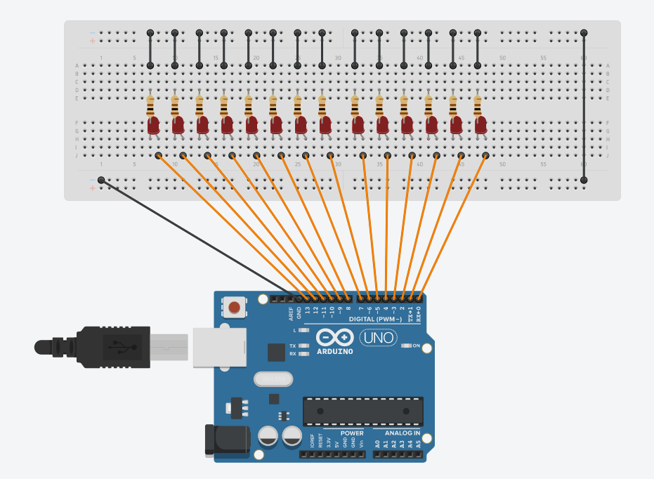

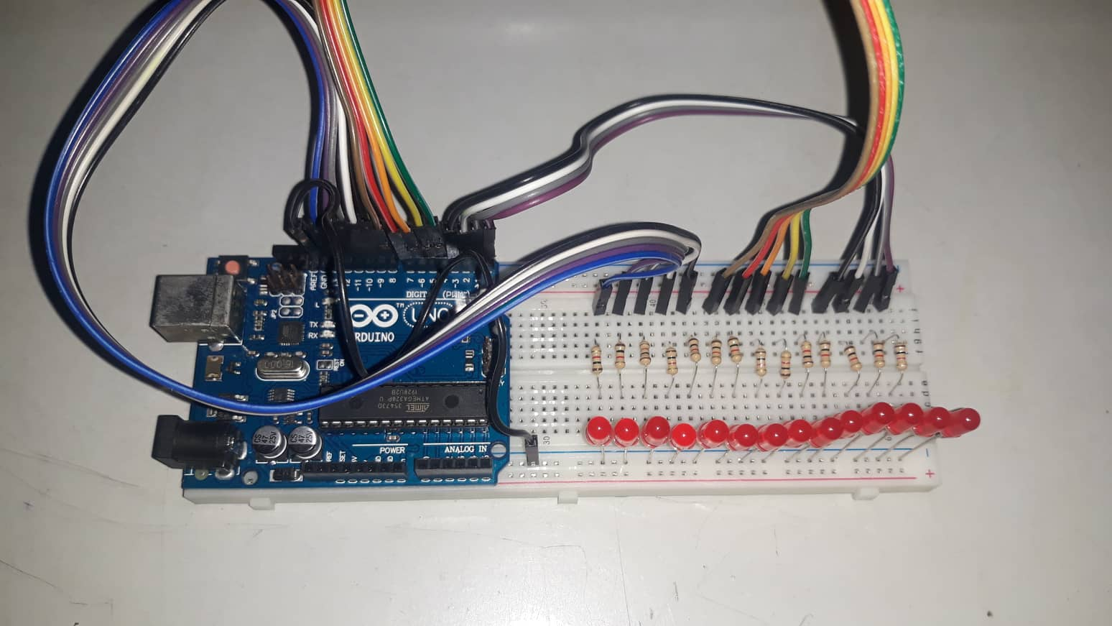

**Observations:**

* There are some issues when there is a wire connected on pin 0 **RX** and pin 1 **TX** during the uploading process.This was resolved by taking out the wire on the pin 0 and 1 before the upload then connecting it back after the upload is done.
* Sometimes the Light Emitting Diodes (LEDs) blinks randomly that is not coded on the Arduino. Possible reasons are the following:

1. There is a short or inductance that affects the wires.
2. The pins of the wires, resistors, or LEDS are sometimes being moved and disconnected from the Arduino or breadboard.
3. There is a problem on the internal connections of the breadboard.